Machine Description | A deliberately vulnerable lab machine for practicing web app exploits, privilege escalation, and post-exploitation to gain user and root access.
Target IP | 192.168.0.197
Vulnerability Name | • SQL Injection Leading to Privilege Escalation  • Weak Web Application Security Controls  • Misconfigured MySQL with Privilege Abuse  • Restricted Shell Bypass
Port / Service | TCP 80 / http
Severity | High 7.4
Attack Vetor | CVSS:3.0/AV:L/AC:H/PR:N/UI:N/S:U/C:H/I:H/A:H
Proof of Concept (PoC) | STEP 1 –  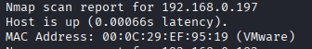  STEP 2 – Nmap Scan to discover open ports and Services  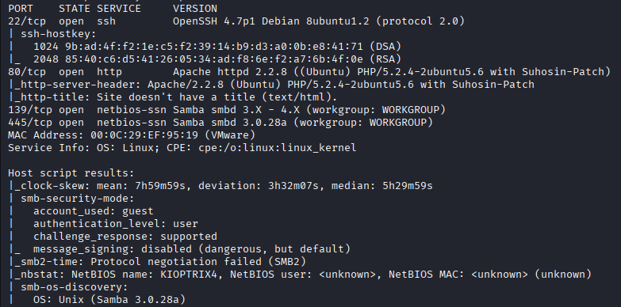  # nmap –p- -sC –sV $ip –open  STEP 3 -We got users through directory wfuzzing.  STEP 4 –SQLi is possible  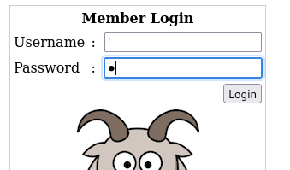  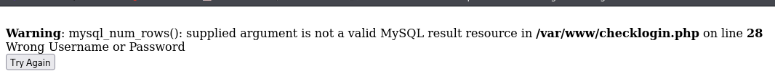  STEP 5 - Found Password for 2 users.  #export url=http://192.168.0.197:80/  #wfuzz –c –z file,/usr/share/Seclists/Fuzzing/SQLi/quick-SQLi.txt –d “myusername=john&mypassword=FUZZ&Submit=Login” –hc 404 $url  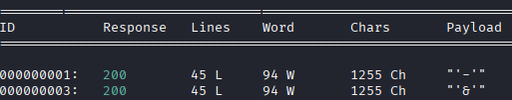  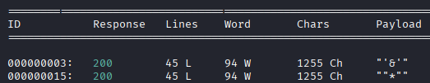  #wfuzz –c –z file,/usr/share/Seclists/Fuzzing/SQLi/quick-SQLi.txt –d “myusername=robert&mypassword=FUZZ&Submit=Login” –hc 404 $url  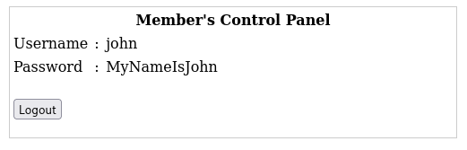  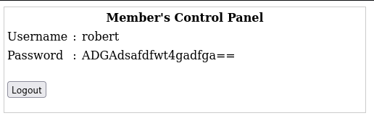  STEP 6 -We got in but it seems that the shell is restricted  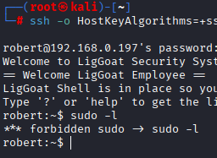  STEP 7 –Break through using echo build in API  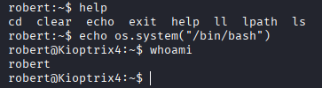  STEP 8 - Found Mysql creds  #grep –Ri ‘sql’ .  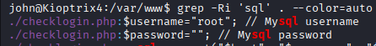  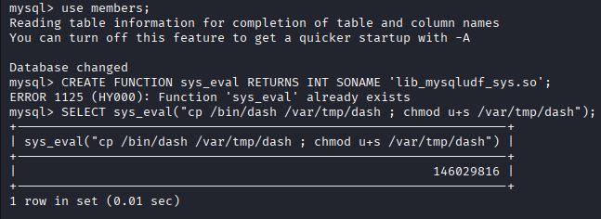  STEP 9 -We exploited a command of mysql i.e. ‘lib_mysqludf_sys.so’ to cp /bin/dash to /var/tmp with root previllages  STEP 10 – We have ROOT!  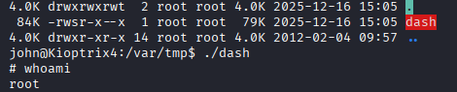
Remediation | • Use prepared statements to prevent SQL Injection  • Validate and sanitize all user input  • Apply strong passwords and remove hardcoded credentials  • Restrict MySQL privileges (avoid running MySQL as root)  • Disable dangerous MySQL functions like lib_mysqludf_sys  • Apply latest security patches and updates  • Use least privilege principle for services and users  • Harden shell access and remove unnecessary binaries
Impact | • Attackers can steal usernames and passwords  • Unauthorized users can log in without valid credentials  • Attackers can execute system commands  • Full root (administrator) access can be gained  • Complete system takeover is possible  • Sensitive data can be modified or deleted
References | https://owasp.org/www-community/attacks/SQL_Injection  https://owasp.org/www-project-top-ten/  https://owasp.org/www-project-top-ten/

